Solution Module 5

Ans 1 : configure the tomcat.

Playbook.yaml

- name: tomcst playbook

  become: yes

  hosts: all

  tasks:

    - name: update cache

      apt:

        update_cache: yes

    - name: install curl

      apt:

        name: curl

        state: present

    - name: install default jdk

      apt:

        name: default-jdk

        state: present

    - name: add group

      group:

        name: tomcat

        state: present

    - name: add user

      user:

        name: tomcat

        shell: /bin/false

        home: /opt/tomcat

        group: tomcat

    - name: download tomcat

      command: chdir=/home/ubuntu/ curl -O https://dlcdn.apache.org/tomcat/tomcat-9/v9.0.73/bin/apache-tomcat-9.0.73.tar.gz

    - name: create tomcat dir

      file:

        path: /opt/tomcat

        state: directory

    - name: install tomcat

      unarchive:

        src: /home/ubuntu/apache-tomcat-9.0.73.tar.gz

        dest: /opt/tomcat

        extra_opts: [--strip-component=1]

        remote_src: true

    - name: dir permission

      file:

        path: /opt/tomcat

        group: tomcat

        owner: tomcat

        mode: g=rx

        recurse: yes

    - name: copy tomcat.service

      copy:

        src: tomcat.service

        dest: /etc/systemd/system

    - name: daemon reload

      systemd:

        daemon_reload: yes

    - name: start tomcat

      systemd:

        name: tomcat

        state: restarted

        enabled: yes

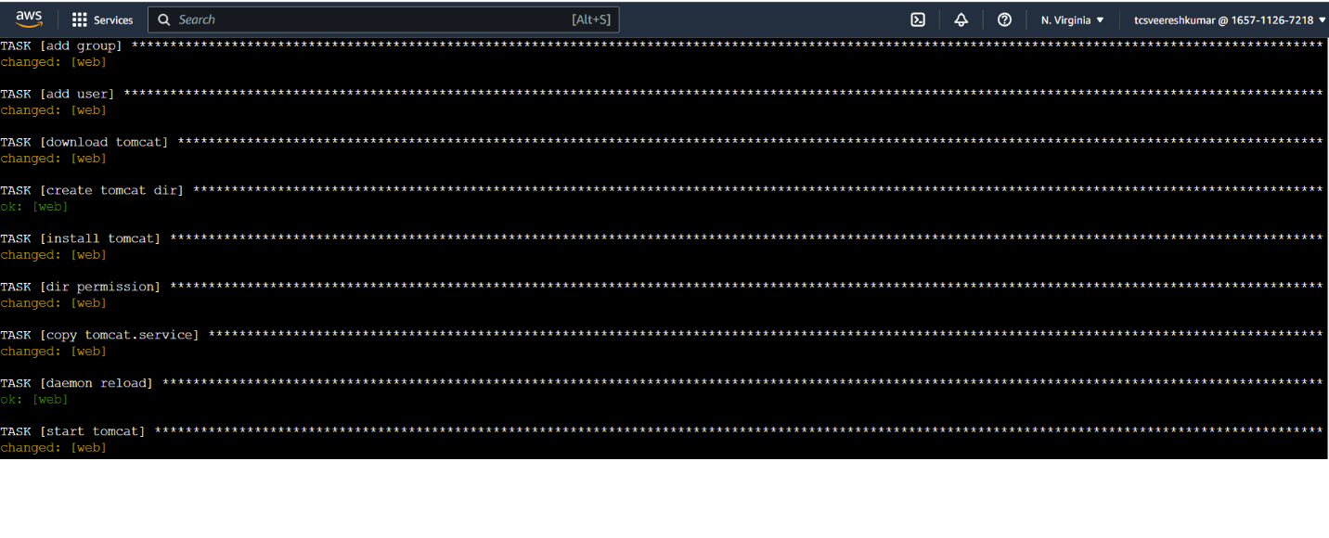out put

Ans 2: maven playbook

Playbook

- name: maven playbook

  become: yes

  hosts: all

  tasks:

    - name: add repo

      ansible.builtin.apt_repository:

        repo: ppa:webup8team/java

    - name: update

      apt:

        update_cache: yes

    - name: maven download

      command: chdir=/home/ubuntu/ wget https://dlcdn.apache.org/maven/maven-3/3.9.1/binaries/apache-maven-3.9.1-bin.tar.gz

    - name: extract

      unarchive:

        src: /home/ubuntu/apache-maven-3.9.1-bin.tar.gz

        dest: /home/ubuntu/

        remote_src: true

    - name: install maven

      command: sudo update-alternatives --install /usr/bin/mvn maven /opt/apache-maven-3.9.1/bin/mvn 1001

output

